**Name: PARAS RATHI**

**Roll No: BIT-24S-007**

**Lab 6:**

**Task 1:**

Basic Task: Write a for loop to print the first 10 natural numbers.

**Program:**

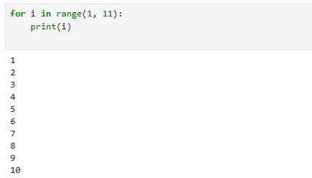

**Task 2:**

Intermediate Task: Write a while loop that prints numbers from 10 down to 1

**Program:**

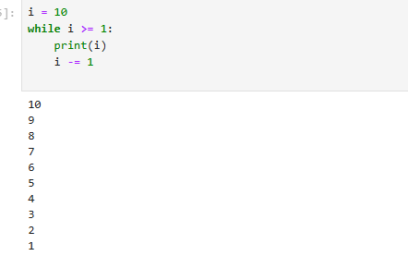

**Task 3:**

Advanced Task: Create a program that uses a for loop to iterate over a string and count the number of vowels.

**Program:**

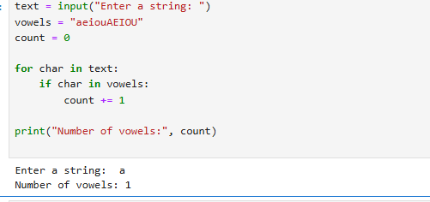

**Challenge Task:**

Write a program that prints the Fibonacci series up to n terms using a while loop.

**Program:**

